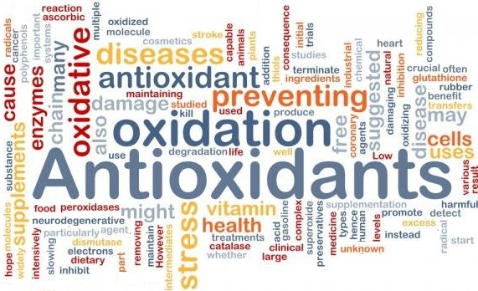

What Are Anti-oxidants/ORAC Points?

An anti-oxidant is a molecule that inhibits or neutralizes the oxidation of other molecules. Oxidation is a chemical reaction involving the loss of electrons or an increase in oxidation state. Oxidation reactions produce free radicals. In turn, these free radicals can start chain reactions. When the chain reaction occurs in a cell, it can cause damage or death to the cell. Anti-oxidants terminate these chain reactions by balancing and neutralizing free radicals.

What are ORAC Points?

O.R.A.C.

How Do Free Radicals Attack You?
Free radicals are highly unstable chemical buzz-bombs that continuously bombard the delicate membranes and genetic structures (DNA) of your cells. This can cause your genetic code to change slightly as your cells replicate. These changes are known as mutations and they can snowball dangerously over time, creating more and more problems. Scientists now know that free radical damage is at the very root of everything from wrinkles to frightening degenerative diseases like arthritis, cancer and heart disease. What are you doing to protect yourself?

Where Do Free Radicals Come From?
Throughout your entire lifetime - every second of every day - your body produces huge amounts of free radicals as a by-product of your metabolism. You produce free radicals even faster in times of stress, disease and exercise. You also pick them up from pollutants in the air such as cigarette smoke, exhaust fumes, sunlight, food additives, pharmaceuticals and other pollutants. Today's environment is an absolute cesspool of free radicals, and the situation is getting worse every day!

How Does Your Body Defend Against Free Radicals?
Fruits, vegetables and certain other foods provide you with an array of nutrients that naturally prevent the formation of free radicals in the body. These nutrients are known as anti-oxidants. Nutrients protect you by inactivating free radicals before they can do any harm. These nutrients are called free radical scavengers. Unfortunately, studies show that today's commercially produced fruits and vegetables no longer contain the amount of nutrients they used to. And even if they did, our atmosphere has become so polluted that you can no longer get enough free radical fighters from food alone, even if you eat the recommended 5 - 9 servings of fruits and vegetables per day!
In other words, it's now IMPOSSIBLE to adequately protect yourself from free radical damage unless you supplement your diet with effective free radical-fighting nutrients. No wonder so many people suffer from cancer, diabetes and other mystery diseases!

Which Antioxidants And Free Radical Scavengers Does Your Body Need?

There are hundreds, probably thousands, of different substances that can act as antioxidants. The most well-known ones are vitamin C, vitamin E, beta-carotene, and other related carotenoids, along with the minerals selenium and manganese. Also glutathione, coenzyme Q10, lipoic acid, flavonoids, phenols, polyphenols, phytoestrogens, and many more.

There are five cultures in the world that have average life spans of between 120 and 140 years:
•The Tibetans in Western China •The Hunzas in Eastern Pakistan •The Russian Georgians •The Armenians •The Abkhasians •Azerbaijanis •Vilcabamba •Ecuador near Lake Titicaca in Peru Bolivia.

The secret of their longevity is "Glacier Milk”: A ). This “Glacial Milk” contains the 90 essential nutrients the body requires daily.

Dr. Wallach recommends that you intake a minimum of 20,000 ORAC points a day to repair damaged cells. If you have more serious soft tissue issues, over 100,000 ORAC points per day are recommended.

EXAMPLES OF ORAC VALUES IN YOUNGEVITY PRODUCTS:
• Beyond Tangy Tangerine 2.0 has 8000 ORAC points per 2 scoops.
• Triple Treat™ Chocolate has 16,936 ORAC points per 1 piece.
• Cell Shield RTQ™ has 15,800 ORAC points per 2 capsules.
• ZRadical™ has about 150,000 ORAC points per bottle.
• Cocogevity Plus™ has about 135,000 per liter3,000 ORAC points per serving
• Maqui Plus™ has 135,000 ORAC points per liter.

EXAMPLES OF ORAC VALUES IN FOOD: Note: 100g = 1/2 cup to 1 cup, depending on the weight of the food.
• Spices, cloves, ground: 290,283 ORAC points / 100g
• Spices, cinnamon, ground: 131,420 ORAC points / 100g
• Acai, fruit pulp/skin, powder: 102,700 ORAC points / 100g
• Elderberries (raw): 14,697 ORAC points / 100g
• Nuts, walnuts, english (raw): 13,541 ORAC points / 100g
• Cranberries (raw): 9,090 ORAC points / 100g
• Plums, dried (prunes), uncooked: 8,059 ORAC points / 100g
• Blackberries (raw): 5,905 ORAC points / 100g
• Apples, Granny Smith, raw, with skin: 3,898 ORAC points / 100g
• Cherries, sweet, raw: 3,747 ORAC points / 100g
• Alcoholic beverage, wine, table, red: 3,607 ORAC points / 100g
• Raisins, seedless: 3,406 ORAC points / 100g
• Goji berry (wolfberry), raw: 3,290 ORAC points / 100g
• Avocados, Hass, raw: 1,922 ORAC points / 100g

